Assignment 2

By

Members of COS80011_A02_T006

Member Subject

s100001252 COS80011

s100864730 COS80011

s101665196 COS80011

Swinburne universtity of Technology

Subject Title: Web application architectures

Assignment number: assingment 02

Due Date: 23 May 2017, 12:00pm

Lab Group: Tuesday 19:30-21:30

Lecturer: Prof Jun Han

Contents

Design and operation of each component 4

Book Inventory Service(Web service) 4

Student Soap Service(web service) 8

Structure of Database 9

ERD Diagram 9

Server01 10

Server02 10

Tables Schema 10

How tables update 12

Book Shop Service(Web service) 12

13

UML Collaboration diagram 13

**BPEL design** 14

At high level, the BPEL design is as **Figure 2** 14

# Design and operation of each component

## Book Inventory Service(Web service)

Book inventory service is a Soap API that connect with database and get some information from database. Book inventory service has access to two tables:

1. Books Table

2. Student borrow Table

This service use XML to transport message .Main class that runs all services for book inventory called UniLibBook. Xml file help service to create url for web api. Inventory Service has some functions as below to run services:

/** get all book in unilib

*

* **@return** all book in String format

*/

**public** String getAllBook()

**endpoint**: http://192.168.1.229:9763/services/UniLibBook.UniLibBookHttpEndpoint/

**weburl**: <http://192.168.1.229:9763/services/UniLibBook.UniLibBookHttpEndpoint/Books>

/**get records of one specific student

*

* **@param** studentId

* **@return** student details in String format

*/

**public** String getRecordsStudent(Integer studentId)

**endpoint**: http://192.168.1.229:9763/services/UniLibBook.UniLibBookHttpEndpoint/

**weburl**: <http://192.168.1.229:9763/services/UniLibBook.UniLibBookHttpEndpoint/student-borrow/%3F>

/**get records of one specific student just different version and it gives more infor

*

* **@param** studentId

* **@return** student details in String format

*/

**public** String getRecordsStudent2(Integer studentId)

/**get all student details

*

* **@param** studentId

* **@return** all student details in string format

*/

**public** String getAllStudentRecords()

**endpoint**:

http://localhost:9763/services/Ass02BookSoap.Ass02BookSoapHttpSoap11Endpoint/

/**view details of a specific book by book id

*

* **@param** bookId

* **@return** detail of that specific book in string format

*/

**public** String getBook(Integer bookId)

/**update book detail by bookid

*

* **@param** bookid

* **@param** title

* **@param** authorList

* **@param** isbn

* **@param** publishDate

* **@param** status

* **@return** String message if it is successfull

* **@throws** BookException

*/

**public** String updateBook(Integer bookid,String title,String authorList,String isbn,String publishDate,String publisher,String status) **throws** BookException

/**function to add book with all details

*

* **@param** bookTitle

* **@param** authorList

* **@param** isbn

* **@param** publisher

* **@param** publishDate

* **@param** status

* **@return** string of successful or error message

* **@throws** BookException

*/

**public** String addBook(String bookTitle,String authorList,String isbn,String publisher,String

publishDate,String status) **throws** BookException

/**easier way of adding book just for test other elements are default

*

* **@param** bookTitle

* **@param** isbn

* **@return** String that shows if book inserted successfully

* **@throws** BookException

*/

**public** String addBook2(String bookTitle,String isbn) **throws** BookException

/**delete the book with book id

*

* **@param** bookId

* **@return** if it is deleted shows bookid... deleted successfully

* **@throws** BookException

*/

**public** String deleteBook(Integer bookId) **throws** BookException

/** action in database has to be borrow request or return (although if a student return the book we delete the that record)

*

* **@param** action

* **@return**

*/

**private** **boolean** isActionValid(String action)

/**update current student record search by studentid and bookid and change action(e.g to returned)

* it just change the action if it exist

* **@param** studentId

* **@param** bookId

* **@param** action

* **@return** if all good it shows action successfully in string format

* **@throws** BookException

*/

**public** String updateStudentrecords(Integer studentId,Integer bookId,String action) **throws** BookException

/** function to insert student borrow record. so they can update if they have existing record

*

* **@param** studentId

* **@param** bookId

* **@param** action

* **@return** if it insert successfully it return successfull message

* **@throws** BookException

*/

**public** String insertStudentrecords(Integer studentId,Integer bookId,String action) **throws** BookException

/** delete student record if it exist for that specific studentId and bookId

*

* **@param** studentId

* **@param** bookId

* **@return** successfull message if delete student records successfully

*/

**public** String deleteStudentrecords(Integer studentId,Integer bookId)

/**function to setBookStatus in case that you gonna change status

*

* **@param** bookId

* **@param** bstatus

* **@return** return successfull if it set status for bookdb

* **@throws** BookException

*/

**public** String setBookStatus(String bookId,String bstatus) **throws** BookException

<service name=*"UniLibBook"* scope=*"application"*>

<description>

Please Type your service description here

</description>

<transports>

<transport>http</transport>

</transports>

<messageReceivers>

<messageReceiver mep=*"http://www.w3.org/2004/08/wsdl/in-only"* class=*"org.apache.axis2.rpc.receivers.RPCInOnlyMessageReceiver"* />

<messageReceiver mep=*"http://www.w3.org/2004/08/wsdl/in-out"* class=*"org.apache.axis2.rpc.receivers.RPCMessageReceiver"*/>

</messageReceivers>

<parameter locked=*"false"* name=*"ServiceClass"*>au.edu.swin.waa.UniLibBook</parameter>

<parameter name=*"disableSOAP11"*>true</parameter>

<parameter name=*"disableSOAP12"*>true</parameter>

<operation name=*"addBook"*>

<parameter name=*"RESTMethod"*>POST</parameter>

<parameter name=*"RESTLocation"*>Books</parameter>

</operation>

<operation name=*"addBook2"*>

<parameter name=*"RESTMethod"*>POST</parameter>

<parameter name=*"RESTLocation"*>Books2</parameter>

</operation>

<operation name=*"updateBook"*>

<parameter name=*"RESTMethod"*>PUT</parameter>

<parameter name=*"RESTLocation"*>Book/{bookId}</parameter>

</operation>

<operation name=*"updateStudentrecords"*>

<parameter name=*"RESTMethod"*>PUT</parameter>

<parameter name=*"RESTLocation"*>studentRecord/{studentId}/{bookId}</parameter>

</operation>

<operation name=*"insertStudentrecords"*>

<parameter name=*"RESTMethod"*>POST</parameter>

<parameter name=*"RESTLocation"*>studentRecords</parameter>

</operation>

<operation name=*"deleteStudentrecords"*>

<parameter name=*"RESTMethod"*>POST</parameter>

<parameter name=*"RESTLocation"*>studentRecord/{studentId}/{bookId}</parameter>

</operation>

<operation name=*"setBookStatus"*>

<parameter name=*"RESTMethod"*>PUT</parameter>

<parameter name=*"RESTLocation"*>book/{bookId}</parameter>

</operation>

<operation name=*"deleteBook"*>

<parameter name=*"RESTMethod"*>DELETE</parameter>

<parameter name=*"RESTLocation"*>Book\{bookId}</parameter>

</operation>

<operation name=*"getBook"*>

<parameter name=*"RESTMethod"*>GET</parameter>

<parameter name=*"RESTLocation"*>Book/{bookId}</parameter>

</operation>

<operation name=*"getRecordsStudent"*>

<parameter name=*"RESTMethod"*>GET</parameter>

<parameter name=*"RESTLocation"*>student-borrow/{studentId}</parameter>

</operation>

<operation name=*"getRecordsStudent2"*>

<parameter name=*"RESTMethod"*>GET</parameter>

<parameter name=*"RESTLocation"*>student-borrow2/{studentId}</parameter>

</operation>

<operation name=*"getAllBook"*>

<parameter name=*"RESTMethod"*>GET</parameter>

<parameter name=*"RESTLocation"*>Books</parameter>

</operation>

<operation name=*"deleteBook"*>

<parameter name=*"RESTMethod"*>DELETE</parameter>

<parameter name=*"RESTLocation"*>book/{bookId}</parameter>

</operation>

</service>

Book inventory is exposed to BPEL as

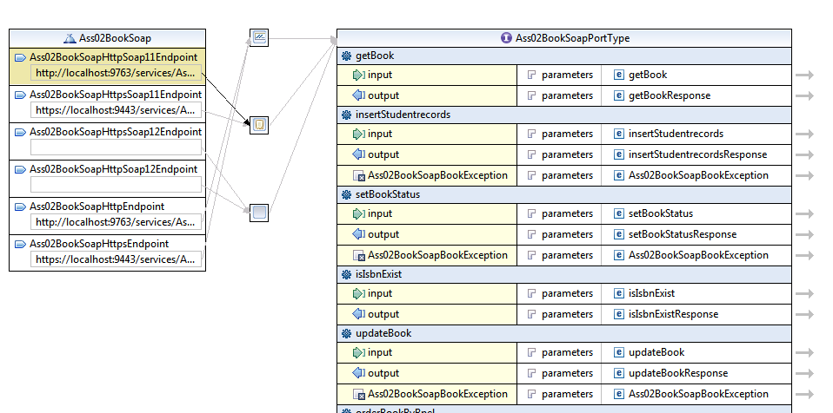

## Student Soap Service(web service)

Student soap service is a Soap api that connect with database and get some information from database. Student soap service has access to one table/database:

1. Students Table

Assumption is that this server is separate from other service(Restfull services), so we cannot use any inner join with book table to get information. This service use XML to transport message .Main class that runs all services for book inventory called UniLibStudent. Student soap Service has some functions as below to run services:

endpoint: <http://192.168.1.229:9763/services/UniLibStudent.UniLibStudentHttpSoap11Endpoint/>

/**this function get all student and return in format of string

*

* **@return** string all student details line by line(it has been used inside application)

*/

**public** String getAllStudent()

/**this function add a new student into database

*

* **@param** fullName

* **@param** pin

* **@return**

* **@throws** StudentException

*/

**public** String addStudent(String fullName,String pin) **throws** StudentException

/** this function remove student from database

*

* **@param** studentId

* **@return**

* **@throws** StudentException

*/

**public** String deleteStudent(Integer studentId) **throws** StudentException

/**this function get student via studentId

*

* **@param** studentId

* **@return**

*/

**public** String getStudent(Integer studentId)

/**this function is for authentication it checks

* if student with the student id and pin exists in database

*

* **@param** studentId

* **@param** pin

* **@return**

*/

**public** String isStudentExist(Integer studentId,String pin)

# Structure of Database

One of the aspects of any software or web/api application is database structure. In this project as we have small block of works we have three main tables, and we assume that book, student borrow records are in one database in lets say server1 and student table in server02 and Google database is connected with Google api and it is not under our control.

## ERD Diagram

As we can see below in diagram, there is no relationship between borrowing records and student(as it is in different server), and inner join is not allowed between these tables.

### Server01

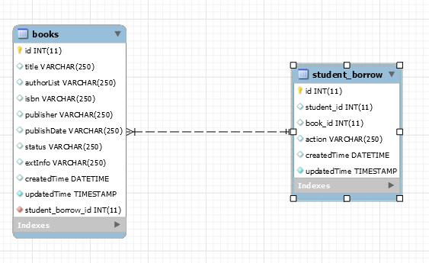

### Server02

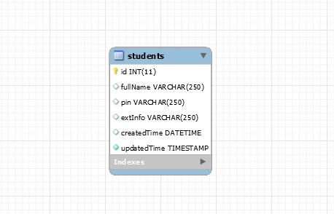

## Tables Schema

`student_borrow` (

`id` INT(11) NOT NULL AUTO_INCREMENT,

`student_id` INT(11) NULL DEFAULT NULL,

`book_id` INT(11) NULL DEFAULT NULL foreign key references waa.books,

`action` VARCHAR(250) NULL DEFAULT NULL,

`createdTime` DATETIME NULL DEFAULT NULL,

`updatedTime` TIMESTAMP NOT NULL DEFAULT CURRENT_TIMESTAMP ON UPDATE CURRENT_TIMESTAMP,

PRIMARY KEY (`id`),

UNIQUE INDEX `student_borrow_uniquekey` (`book_id` ASC))

-- -----------------------------------------------------

-- Table `waa`.`books`

-- -----------------------------------------------------

`books` (

`id` INT(11) NOT NULL AUTO_INCREMENT,

`title` VARCHAR(250) NULL DEFAULT NULL,

`authorList` VARCHAR(250) NULL DEFAULT NULL,

`isbn` VARCHAR(250) NULL DEFAULT NULL,

`publisher` VARCHAR(250) NULL DEFAULT NULL,

`publishDate` VARCHAR(250) NULL DEFAULT NULL,

`status` VARCHAR(250) NULL DEFAULT NULL,

`extInfo` VARCHAR(250) NULL DEFAULT NULL,

`createdTime` DATETIME NULL DEFAULT NULL,

`updatedTime` TIMESTAMP NOT NULL DEFAULT CURRENT_TIMESTAMP ON UPDATE CURRENT_TIMESTAMP,

`student_borrow_id` INT(11) NOT NULL,

PRIMARY KEY (`id`),

UNIQUE INDEX `uq_book_cons` (`isbn` ASC),

-- -----------------------------------------------------

`waa`.`students`

-- -----------------------------------------------------

`students` (

`id` INT(11) NOT NULL AUTO_INCREMENT,

`fullName` VARCHAR(250) NULL DEFAULT NULL,

`pin` VARCHAR(250) NULL DEFAULT NULL,

`extInfo` VARCHAR(250) NULL DEFAULT NULL,

`createdTime` DATETIME NULL DEFAULT NULL,

`updatedTime` TIMESTAMP NOT NULL DEFAULT CURRENT_TIMESTAMP ON UPDATE CURRENT_TIMESTAMP,

PRIMARY KEY (`id`))

## How tables update

The way that tables update follows as below:

**Student request a book:** A new book will be inserted into books table with status back order. Then in borrowing record one new row will be inserted with student_id and book_id and action= back order

The student service is exposed to BPEL as

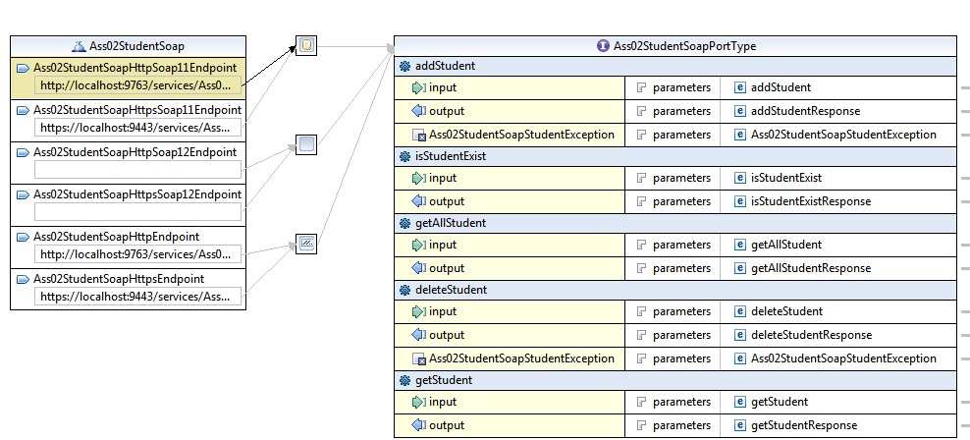

## Book Shop Service(Web service)

End point

<https://localhost/services/Ass02BookInformation.Ass02BookInformationHttpsSoap11Endpoint/>

The book ordering source is implemented as a web service which retrieves the relevant book information from bookshop database, we do not implement Google API service which dynamically retrieve book information online. The bookshop database is shown in **Figure 1**

# 

**Figure 1**

The bookshop service is exposed to BPEL as

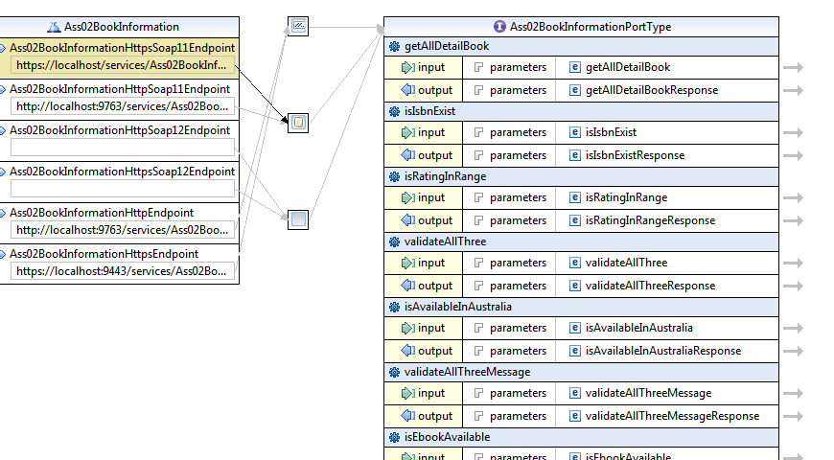

# UML Collaboration diagram

See attached sheet.

**BPEL design**

At high level, the BPEL design is as **Figure 2**

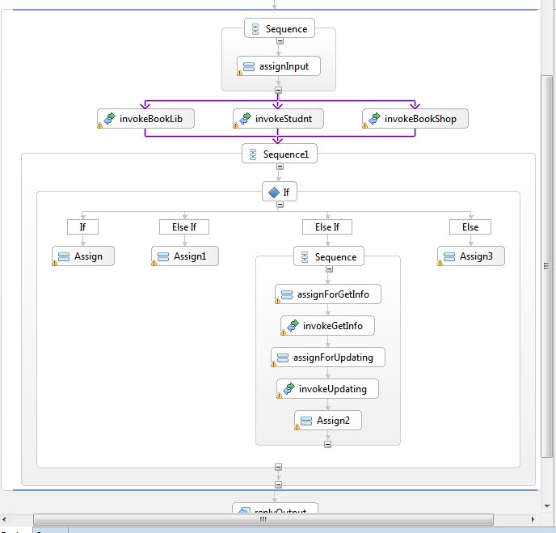

**Figure 2**

The BPEL logic workflows operates as follows.

The above mentioned web service endpints are used as partiner links by BPEL to assis the book ordering process.

1. <https://localhost/services/Ass02BookInformation.Ass02BookInformationHttpsSoap11Endpoint/>
2. <http://localhost:9763/services/Ass02BookSoap.Ass02BookSoapHttpSoap11Endpoint/>
3. <http://localhost:9763/services/Ass02StudentSoap.Ass02StudentSoapHttpSoap11Endpoint/>

all the wsdl operations are available to BPEL calls.

BPEL takes 3 string parameters as inputs: StudentID, pin and ISBN number. The inputs are checked via the web service endpoints by the dabtabase. If failed by any of the three inputs BPEL will return error string to the user. If passed, BPEL will get the book details from Bookshop database and update the book inventory dababase and student borrow record.